mysql> create database TechShop;

mysql> use TechShop;

Database changed

mysql> create table customers

(CustomerID INT PRIMARY KEY AUTO_INCREMENT,

Firstname VARCHAR(50),

Lastname VARCHAR(50),

Email VARCHAR(100),

Phone VARCHAR(100),

Address VARCHAR(255));

Query OK, 0 rows affected (0.06 sec)

mysql> create table products

( ProductID INT PRIMARY KEY AUTO_INCREMENT,

Productname VARCHAR(255),

Description text,

Price DECIMAL(10,2));

Query OK, 0 rows affected (0.04 sec)

mysql> create table orders

( OrderID INT PRIMARY KEY AUTO_INCREMENT,

CustomerID int,

OrderDate DATE,

TotalAmount DECIMAL(10,2),

FOREIGN KEY(CustomerID) REFERENCES customers(CustomerID)

ON DELETE CASCADE

ON UPDATE CASCADE);

Query OK, 0 rows affected (0.07 sec)

mysql> create table orderdetails

(OrderdetailID INT PRIMARY KEY AUTO_INCREMENT,

OrderID INT,

ProductID INT,

Quantity INT,

FOREIGN KEY(OrderID) REFERENCES orders(OrderID) ON DELETE CASCADE ON UPDATE CASCADE,

FOREIGN KEY(ProductID) REFERENCES products(ProductID) ON

DELETE CASCADE ON UPDATE CASCADE);

Query OK, 0 rows affected (0.04 sec)

mysql> create table inventory

(InventoryID INT PRIMARY KEY AUTO_INCREMENT,

ProductID INT,

QuantityInStock INT,

LastStockUpdate DATE,

FOREIGN KEY(ProductID) REFERENCES products(ProductID) ON DELETE CASCADE ON UPDATE CASCADE);

Query OK, 0 rows affected (0.04 sec)

mysql> INSERT INTO customers(Firstname,Lastname,Email,Phone,Address)

values('RAM','GOYAL','ram@gmail.com','1234567890','123 Street rajpur'),

('Raghav','Bansal','raghav@gmail.com','2345678901','213 Street jodhpur'),

('Sohan','Bansal','sohan@gmail.com','3456789012','413 Street Gorakhpur'),

('Sahil','Seth','sahil@gmail.com','4567890123','513 Street Banaras'),

('Bharat','Saxena','bharat@gmail.com','5678901234','913 Street Mumbai'),

('Krishna','Sharma','krishna@gmail.com','6789012345','013 Street Rajkot'),

('Raj','Kumar','raj@gmail.com','7890123456','654 Street Udaipur'),

('Priyank','Garg','priyank@gmail.com','8901234567','234 Street Jharkhand'),

('Gowtham','Gupta','gowtham@gmail.com','9012345678','645 Street Uttrakhand'),

('Kush','Jindal','kush@gmail.com','0123456789','897 Street Dehradun');

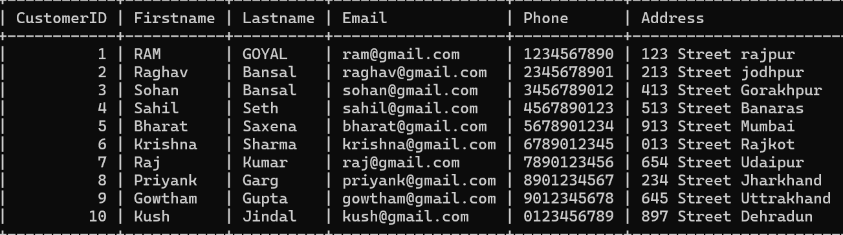

mysql> INSERT INTO products(Productname,Description,Price)

values('HP Laptop','High Performance laptop',799.99),

('Samsung Smartphone','Latest Generation Phone',599.99),

('Oneplus Smartphone','Latest Generation Phone',699.99),

('Iphone 16','Latest Technology Phone',799.99),

('Phillips Home theatre','A high quality audio',399.99),

('Whirpool Referigrator','Best Cooling Equipment',899.99),

('Voltas Air Conditioner','High Quality AC',999.99),

('Bajaj Room Cooler','Best for room cooling',499.99),

('75 inch Sony Bravia','4K display',1299.99),

('75 inch LG TV','8K display',1999.99);

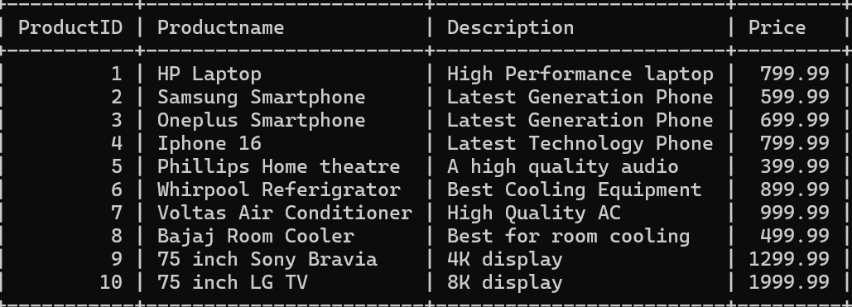

mysql> INSERT INTO orders(CustomerID,OrderDate,TotalAmount)

values(1,'2024-03-03',799.99),

(2,'2024-03-05',1199.98),

(3,'2024-03-04',699.99),

(4,'2024-03-06',2399.97),

(5,'2024-03-06',399.99),

(6,'2024-03-08',899.99),

(7,'2024-03-10',1999.98),

(8,'2024-03-12',2499.95),

(9,'2024-03-12',1299.99),

(10,'2024-03-14',1999.99);

Query OK, 10 rows affected (0.02 sec)

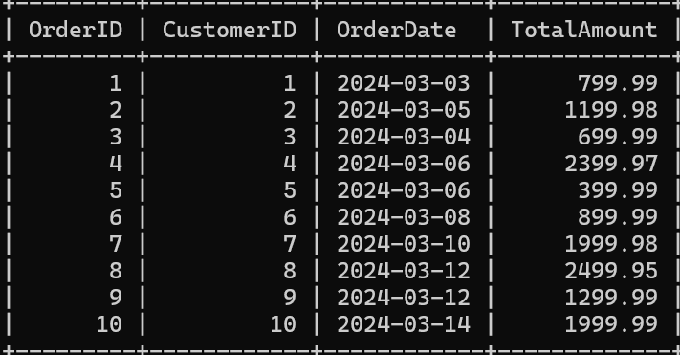

mysql> INSERT INTO orderdetails(OrderID,ProductID,Quantity)

values(1,1,1),

(2,2,2),

(3,3,1),

(4,4,3),

(5,5,1),

(6,6,1),

(7,7,2),

(8,8,5),

(9,9,1),

(10,10,1);

Query OK, 10 rows affected (0.01 sec)

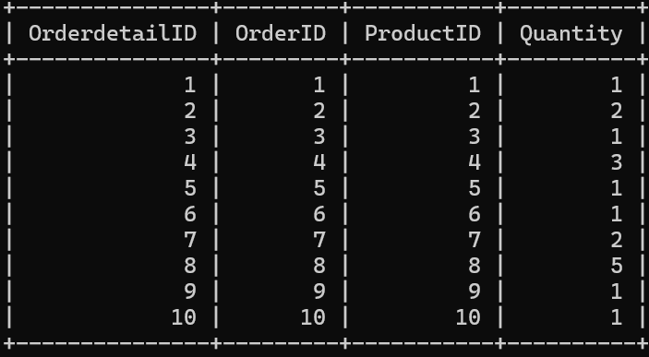

mysql> INSERT INTO inventory(ProductID,QuantityInStock,LastStockUpdate)

values(1,21,'2024-03-20'),

(2,19,'2024-03-20'),

(3,22,'2024-03-20'),

(4,29,'2024-03-20'),

(5,35,'2024-03-20'),

(6,10,'2024-03-20'),

(7,17,'2024-03-20'),

(8,12,'2024-03-20'),

(9,22,'2024-03-20'),

(10,29,'2024-03-20');

Query OK, 10 rows affected (0.01 sec)

